**Suggested practical - Investigating human reaction times**

You can carry out a number of investigations to determine the effect of a specific factor on human reaction times. A suitable investigation could be the effect of caffeine or the amount of background noise in the room. A simple method to measure the effect is to use the ruler drop test.

**Aim**

The aim of this experiment is to determine whether a factor such as caffeine or background noise affects reaction times.

**Ruler drop test**

1. Work with a partner.
2. Person A holds out their hand with a gap between their thumb and first finger.
3. Person B holds the ruler with the zero at the top of person A's thumb.
4. Person B drops the ruler without telling Person A and they must catch it.
5. The number level with the top of person A's thumb is recorded in a suitable table. Repeat this five times.
6. Swap places, and record another five attempts.
7. You can use the conversion table to help convert your ruler measurements into reaction time or just record the catch distance in centimetres.

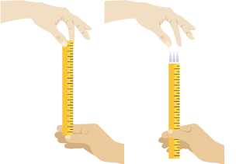

| **Catch distance (cm)** | **Reaction time (ms)** |
| --- | --- |
| 1 | 50 |
| 5 | 90 |
| 10 | 140 |
| 15 | 170 |
| 20 | 200 |
| 25 | 230 |
| 30 | 250 |

One millisecond is one thousandth of a second. It can also be written as 10−3 s.

**Example results**

| **Attempt** | **Distance on ruler (cm)** | **Distance on ruler (cm)** |
| --- | --- | --- |
| **number** | **With noise** | **Without noise** |
| 1 | 25 | 18 |
| 2 | 38 | 15 |
| 3 | 36 | 22 |
| 4 | 31 | 24 |
| 5 | 38 | 13 |
| Average | 33.6 | 18.4 |

**Question**

What affect does noise have on the speed of reaction, measured in centimetres?